|  |  |  |  |  |
| --- | --- | --- | --- | --- |
| 1. [taxonomy]   ALL | [protein]  ALL | [nonmembrane]  ALL | [membrane]  ALL | [evidence]  ALL |

#number of entries = 4030

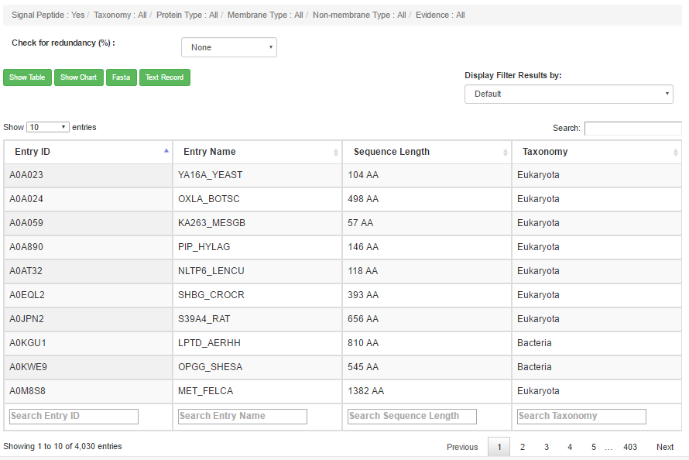

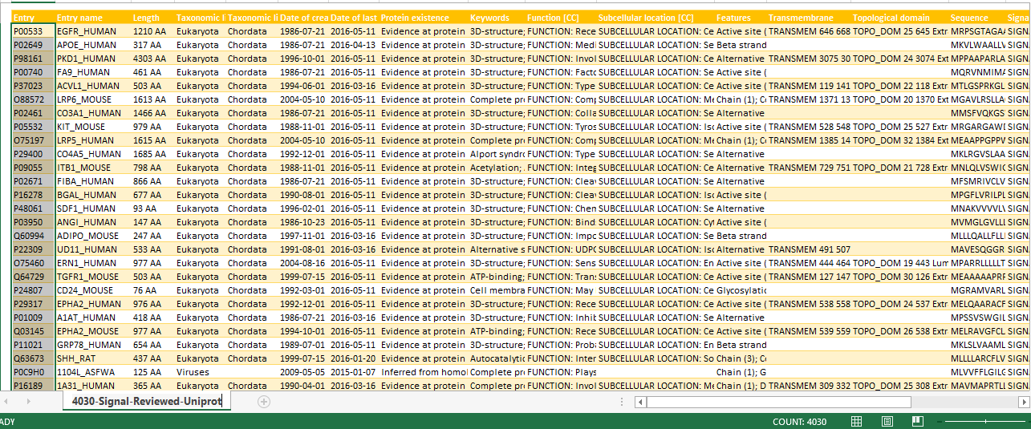

|  |  |  |  |  |
| --- | --- | --- | --- | --- |
| 1. [taxonomy]   ALL | [protein]  ALL | [nonmembrane]  ALL | [membrane]  ALL | [evidence]  Experimental |

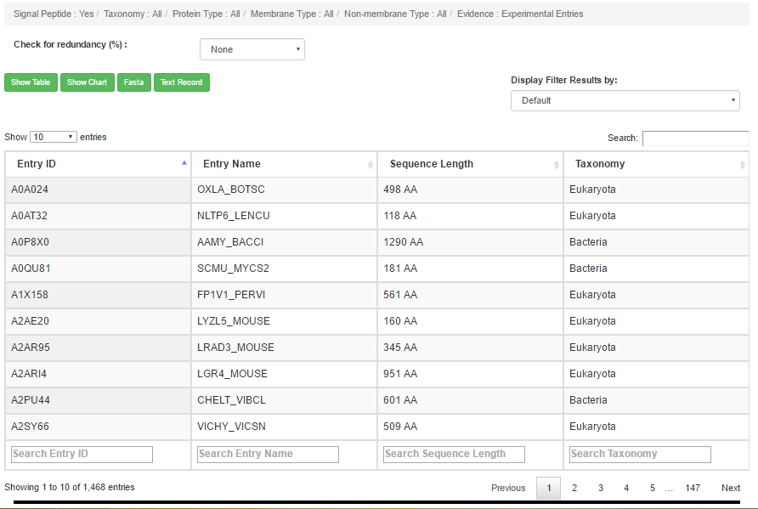

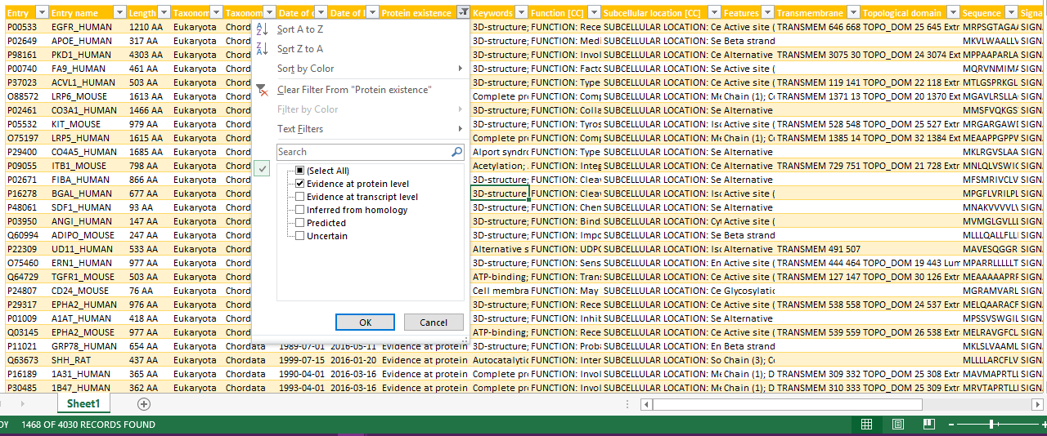

|  |  |  |  |  |
| --- | --- | --- | --- | --- |
| 1. [taxonomy]   ALL | [protein]  ALL | [nonmembrane]  ALL | [membrane]  ALL | [evidence]  Nonexperimental |

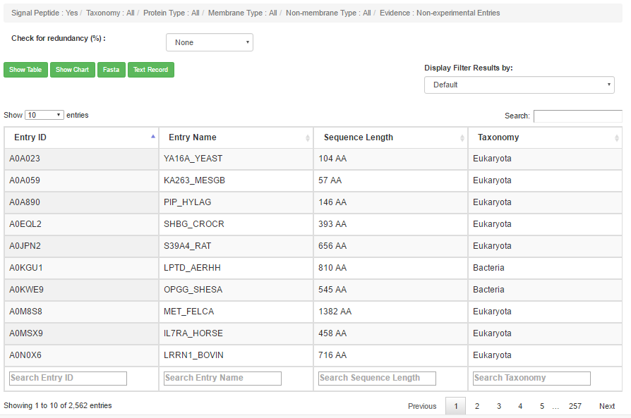

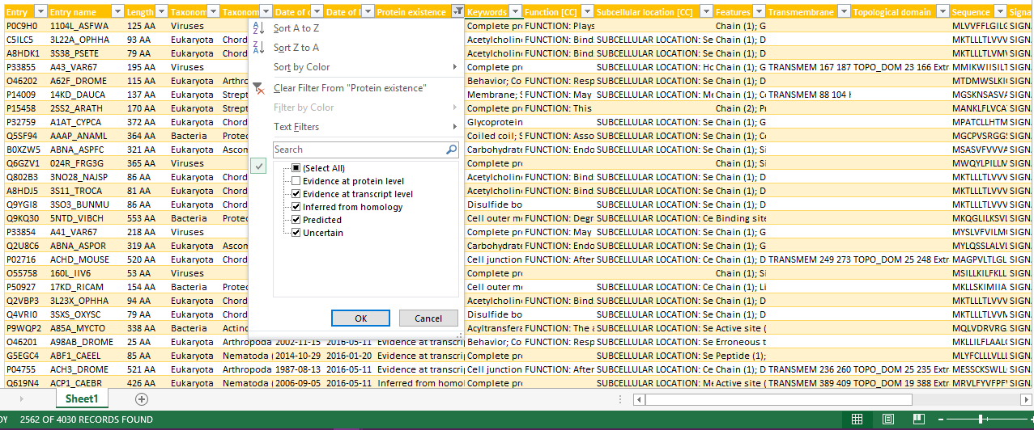

|  |  |  |  |  |
| --- | --- | --- | --- | --- |
| 1. [taxonomy] ALL | [protein] ALL | [nonmembrane] ALL | [membrane] Single-spanning | [evidence] ALL |

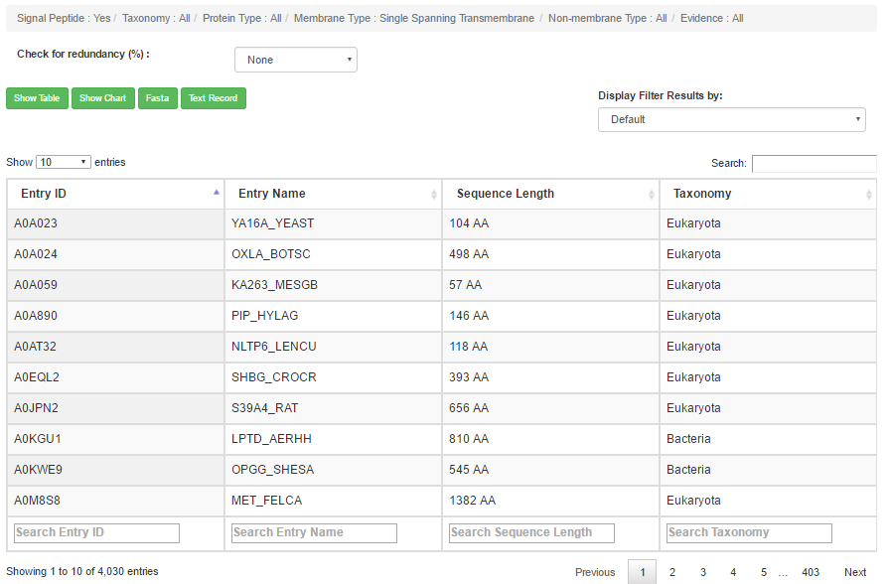

|  |  |  |  |  |
| --- | --- | --- | --- | --- |
| 1. [taxonomy] ALL | [protein] ALL | [nonmembrane] ALL | [membrane] Single-spanning | [evidence] Experimental |

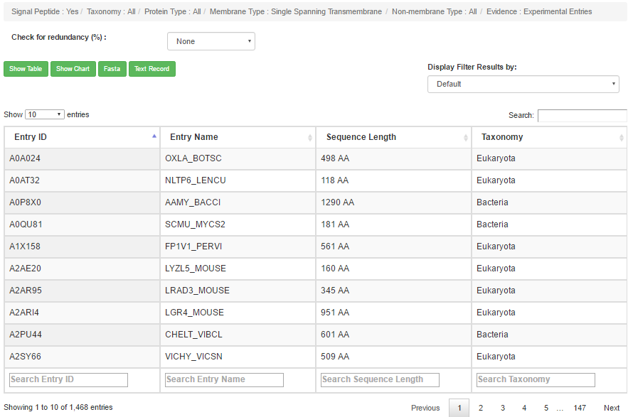

|  |  |  |  |  |
| --- | --- | --- | --- | --- |
| 1. [taxonomy] ALL | [protein] ALL | [nonmembrane] ALL | [membrane] Single-spanning | [evidence] Nonexperimental |

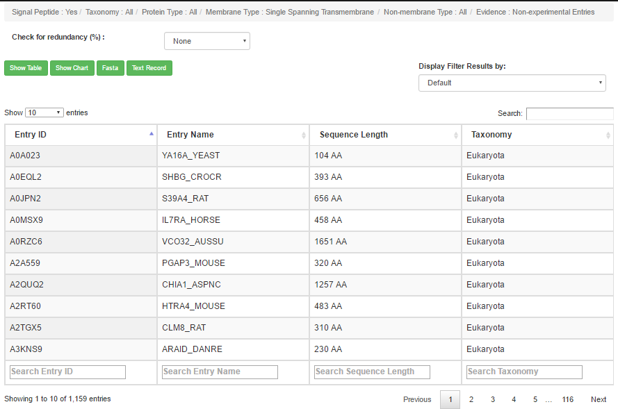

|  |  |  |  |  |
| --- | --- | --- | --- | --- |
| 1. [taxonomy]   ALL | [protein]  ALL | [nonmembrane]  ALL | [membrane]  Multi-spanning | [evidence]  ALL |

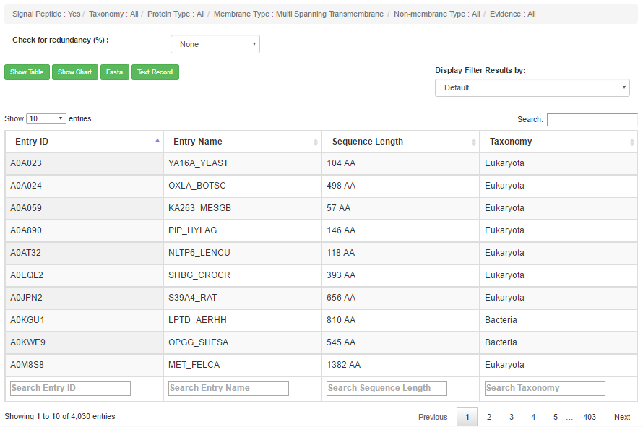

|  |  |  |  |  |
| --- | --- | --- | --- | --- |
| 1. [taxonomy]   ALL | [protein]  ALL | [nonmembrane]  ALL | [membrane]  Multi-spanning | [evidence]  Experimental |

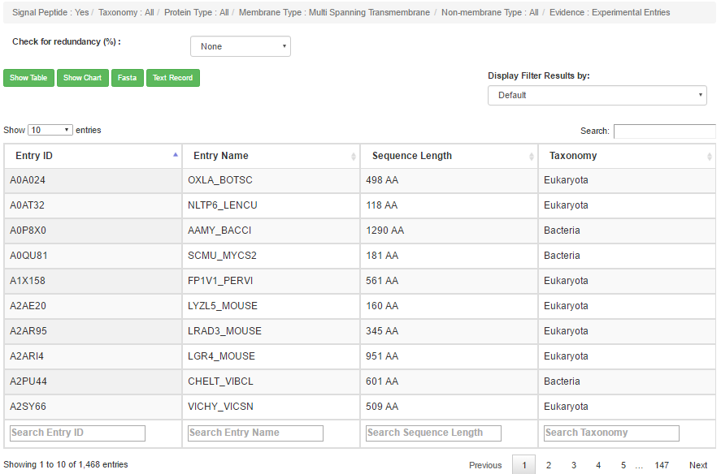

|  |  |  |  |  |
| --- | --- | --- | --- | --- |
| 1. [taxonomy]   ALL | [protein]  ALL | [nonmembrane]  ALL | [membrane]  Multi-spanning | [evidence]  Nonexperimental |

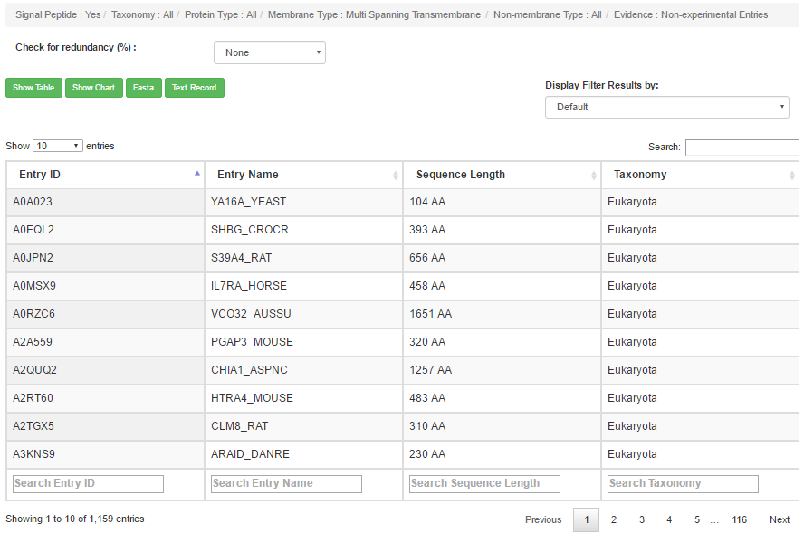

|  |  |  |  |  |
| --- | --- | --- | --- | --- |
| 1. [taxonomy]   ALL | [protein]  ALL | [nonmembrane]  ALL | [membrane]  Beta-barrel | [evidence]  ALL |

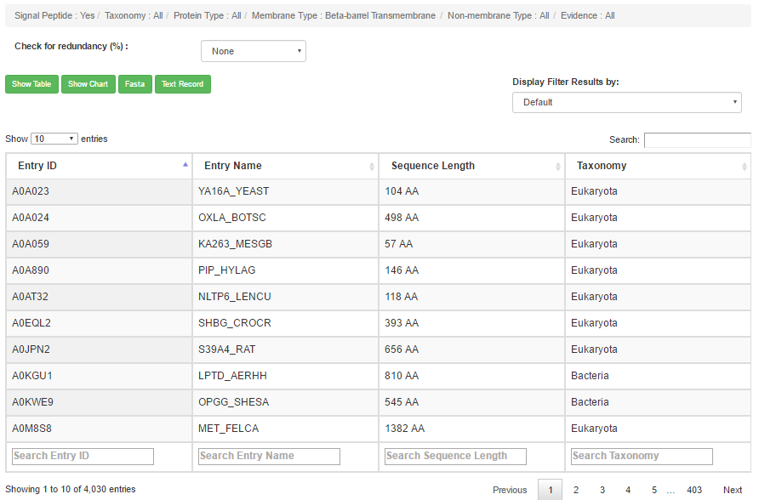

|  |  |  |  |  |
| --- | --- | --- | --- | --- |
| 1. [taxonomy]   ALL | [protein]  ALL | [nonmembrane]  ALL | [membrane]  Beta-barrel | [evidence]  Experimental |

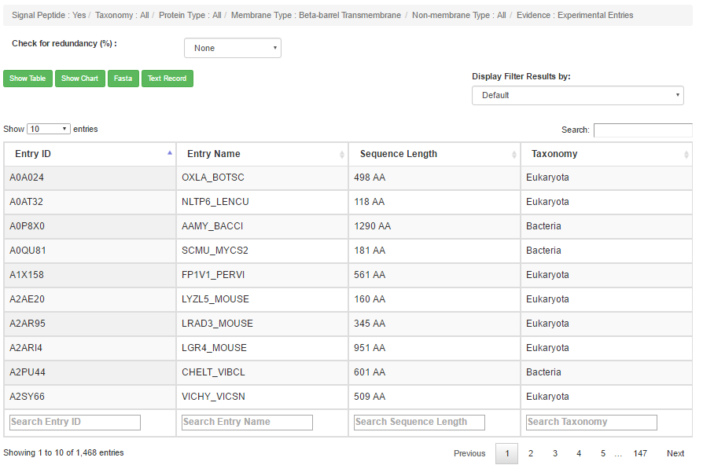

|  |  |  |  |  |
| --- | --- | --- | --- | --- |
| 1. [taxonomy] ALL | [protein] ALL | [nonmembrane] ALL | [membrane] Beta-barrel | [evidence] Nonexperimental |

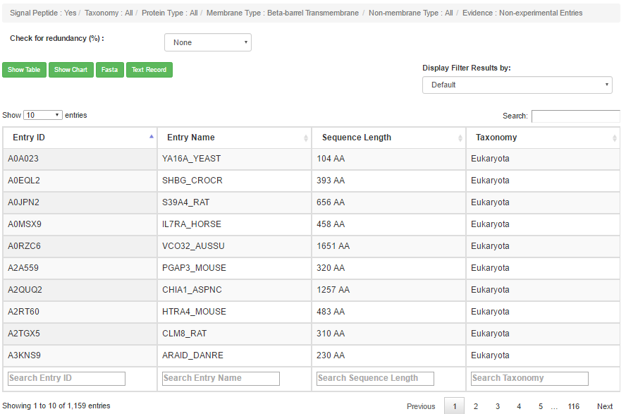

|  |  |  |  |  |
| --- | --- | --- | --- | --- |
| 1. [taxonomy] ALL | [protein] ALL | [nonmembrane] Secretory | [membrane] ALL | [evidence] ALL |

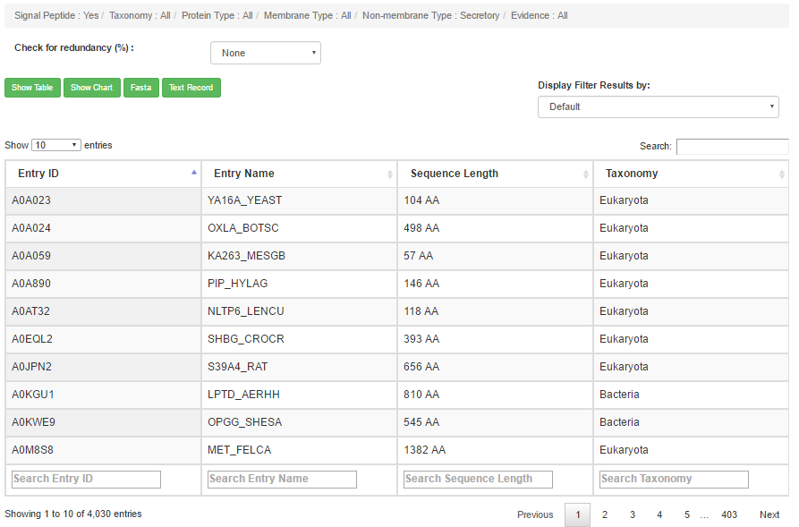

|  |  |  |  |  |
| --- | --- | --- | --- | --- |
| 1. [taxonomy] ALL | [protein] ALL | [nonmembrane] Secretory | [membrane] ALL | [evidence] Experimental |

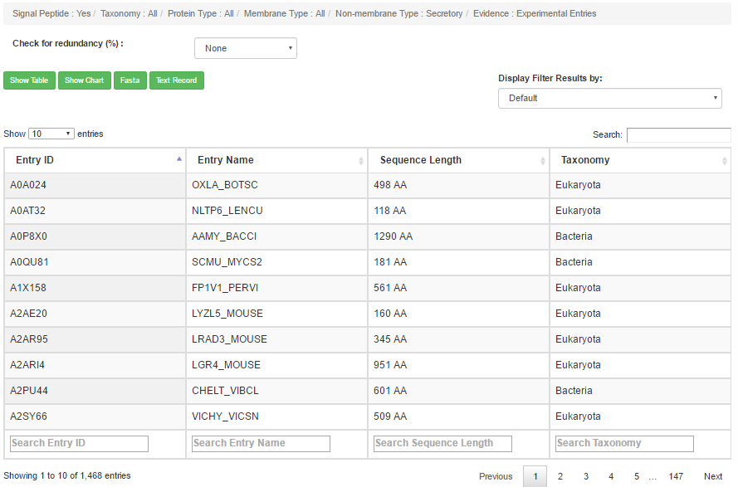

|  |  |  |  |  |
| --- | --- | --- | --- | --- |
| 1. [taxonomy] ALL | [protein] ALL | [nonmembrane] Secretory | [membrane] ALL | [evidence] Nonexperimental |

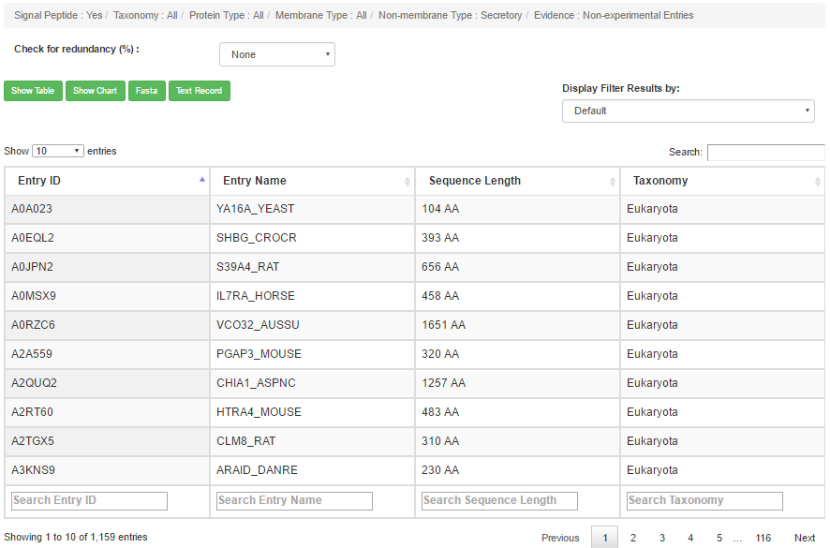

|  |  |  |  |  |
| --- | --- | --- | --- | --- |
| 1. [taxonomy] ALL | [protein] ALL | [nonmembrane] Secretory | [membrane] Single-spanning | [evidence] ALL |

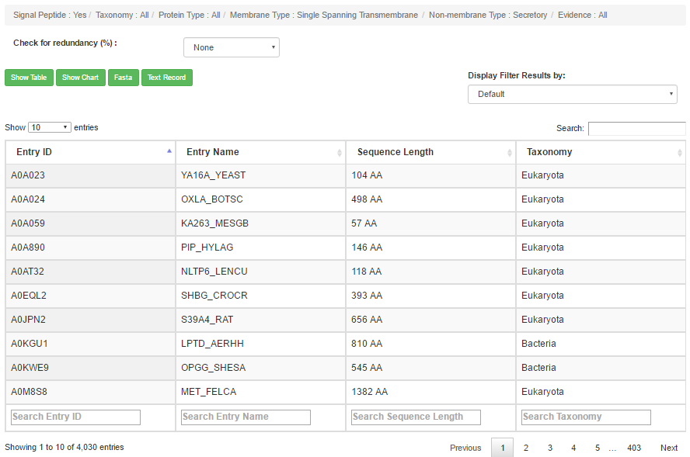

|  |  |  |  |  |
| --- | --- | --- | --- | --- |
| 1. [taxonomy] ALL | [protein] ALL | [nonmembrane] Secretory | [membrane] Single-spanning | [evidence] Experimental |

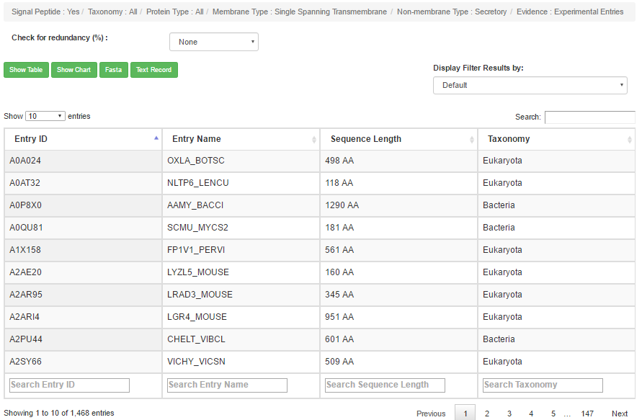

|  |  |  |  |  |
| --- | --- | --- | --- | --- |
| 1. [taxonomy] ALL | [protein] ALL | [nonmembrane] Secretory | [membrane] Single-spanning | [evidence] Nonexperimental |

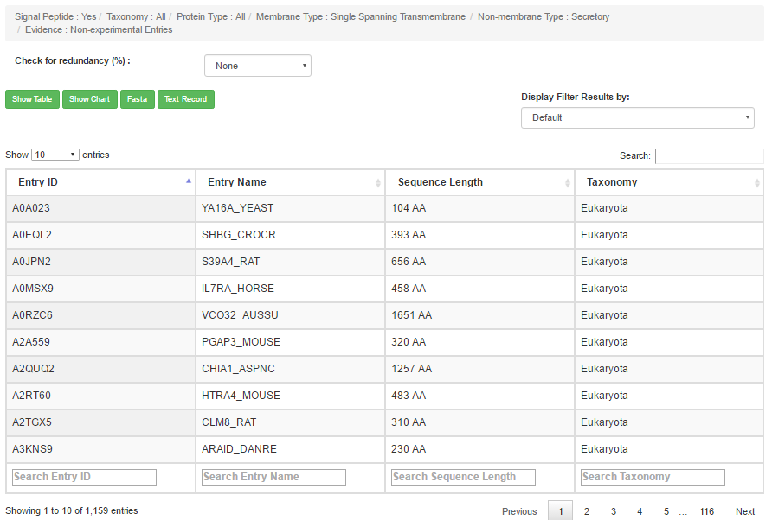

|  |  |  |  |  |
| --- | --- | --- | --- | --- |
| 1. [taxonomy] ALL | [protein] ALL | [nonmembrane] Secretory | [membrane] Multi-spanning | [evidence] ALL |

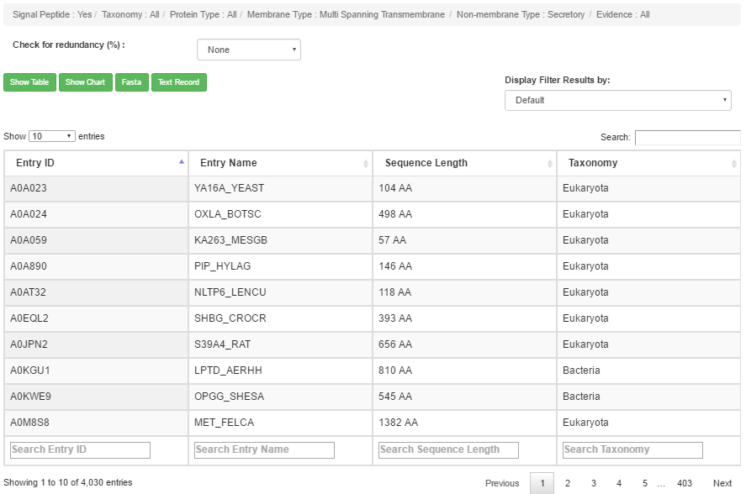

|  |  |  |  |  |
| --- | --- | --- | --- | --- |
| 1. [taxonomy] ALL | [protein] ALL | [nonmembrane] Secretory | [membrane] Multi-spanning | [evidence] Experimental |

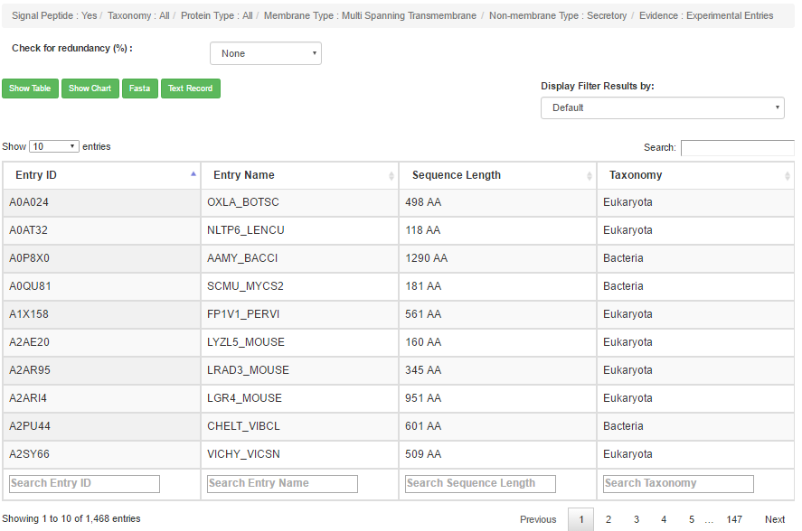

|  |  |  |  |  |
| --- | --- | --- | --- | --- |
| 1. [taxonomy] ALL | [protein] ALL | [nonmembrane] Secretory | [membrane] Multi-spanning | [evidence] Nonexperimental |

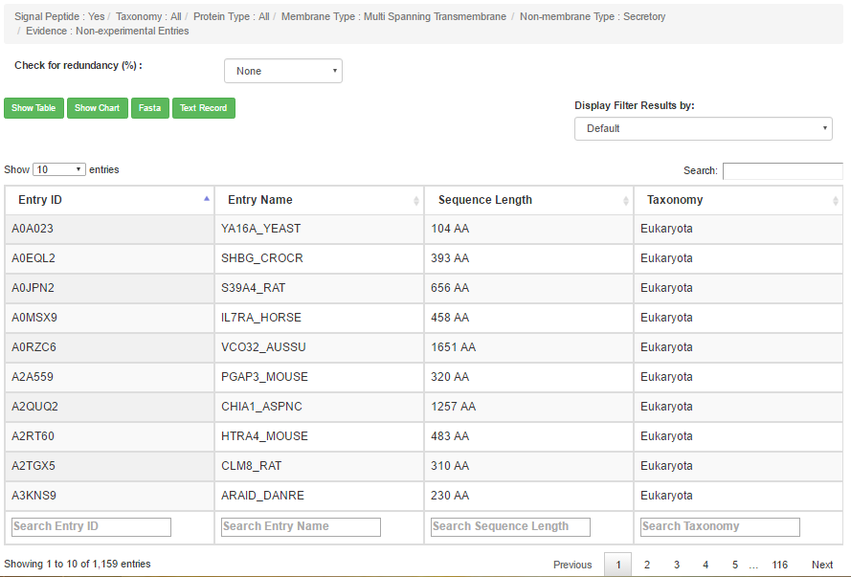

|  |  |  |  |  |
| --- | --- | --- | --- | --- |
| 1. [taxonomy] ALL | [protein] ALL | [nonmembrane] Secretory | [membrane] Beta-barrel | [evidence] ALL |

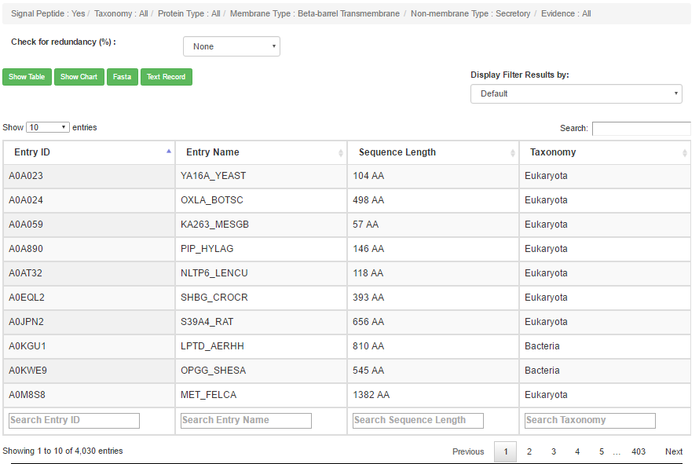

|  |  |  |  |  |
| --- | --- | --- | --- | --- |
| 1. [taxonomy] ALL | [protein] ALL | [nonmembrane] Secretory | [membrane] Beta-barrel | [evidence] Experimental |

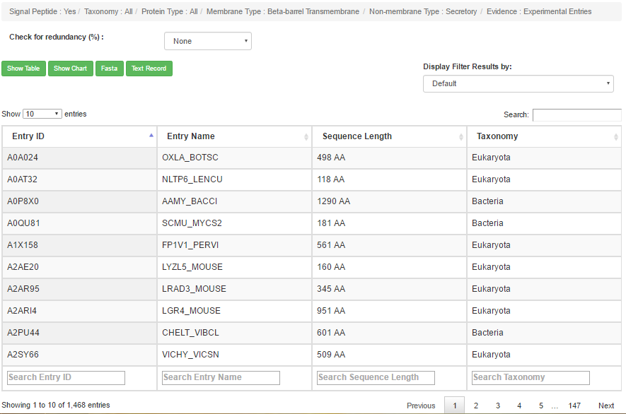

|  |  |  |  |  |
| --- | --- | --- | --- | --- |
| 1. [taxonomy] ALL | [protein] ALL | [nonmembrane] Secretory | [membrane] Beta-barrel | [evidence] Nonexperimental |

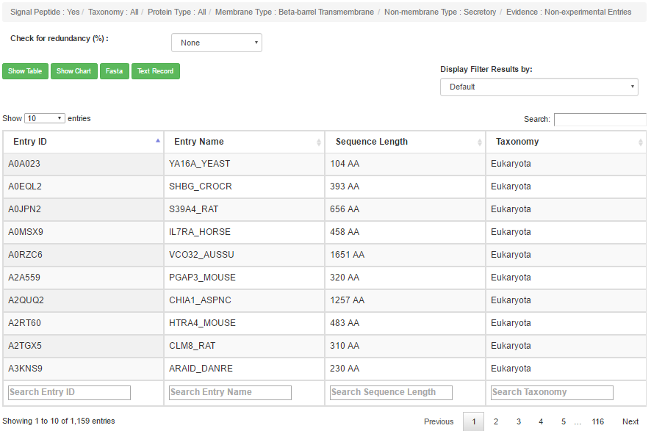

|  |  |  |  |  |
| --- | --- | --- | --- | --- |
| 1. [taxonomy] ALL | [protein] ALL | [nonmembrane] Non-secretory | [membrane] ALL | [evidence] ALL |
| 1. [taxonomy] ALL | [protein] ALL | [nonmembrane] Non-secretory | [membrane] ALL | [evidence] Experimental |

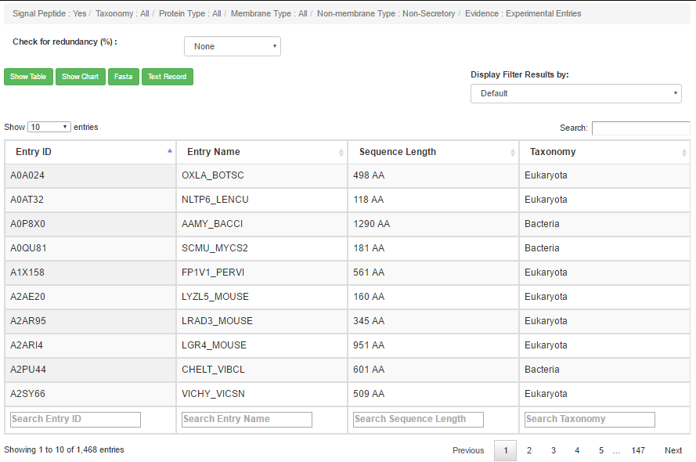

|  |  |  |  |  |
| --- | --- | --- | --- | --- |
| 1. [taxonomy] ALL | [protein] ALL | [nonmembrane] Non-secretory | [membrane] ALL | [evidence] Nonexperimental |

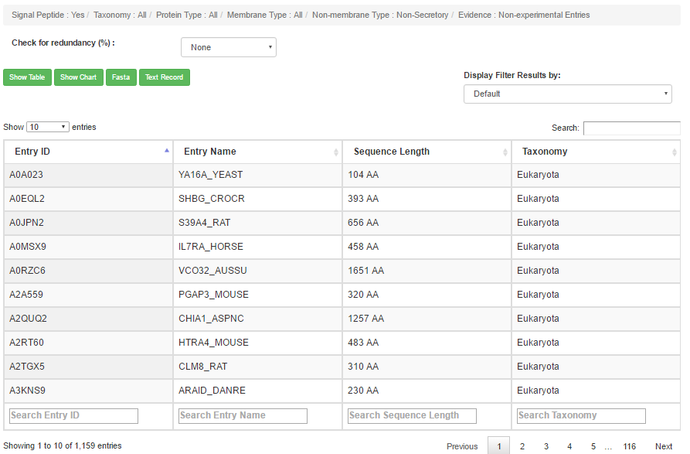

|  |  |  |  |  |
| --- | --- | --- | --- | --- |
| 1. [taxonomy] ALL | [protein] ALL | [nonmembrane] Non-secretory | [membrane] Single-spanning | [evidence] ALL |
| 1. [taxonomy] ALL | [protein] ALL | [nonmembrane] Non-secretory | [membrane] Single-spanning | [evidence] Experimental |

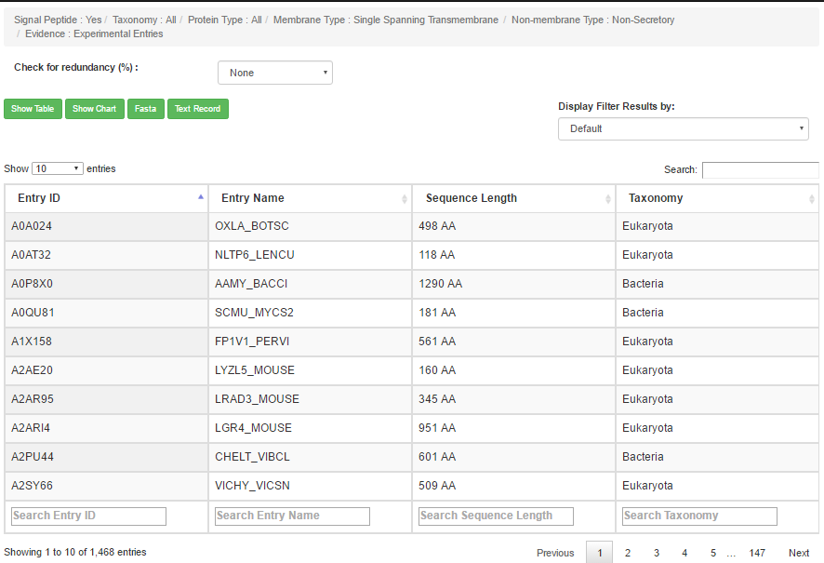

|  |  |  |  |  |
| --- | --- | --- | --- | --- |
| 1. [taxonomy] ALL | [protein] ALL | [nonmembrane] Non-secretory | [membrane] Single-spanning | [evidence] Nonexperimental |

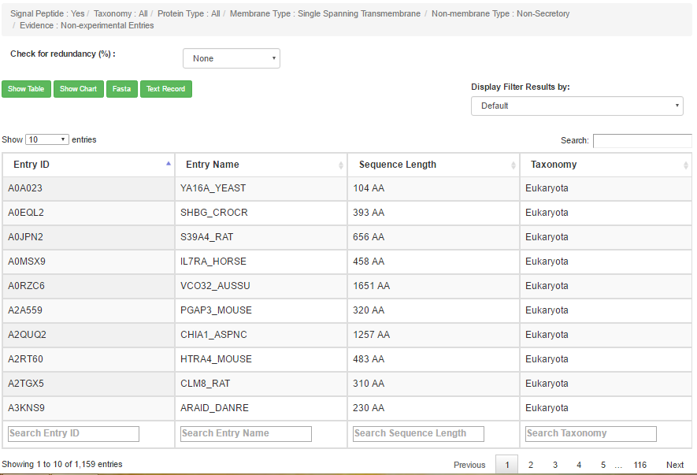

|  |  |  |  |  |
| --- | --- | --- | --- | --- |
| 1. [taxonomy] ALL | [protein] ALL | [nonmembrane] Non-secretory | [membrane] Multi-spanning | [evidence] ALL |

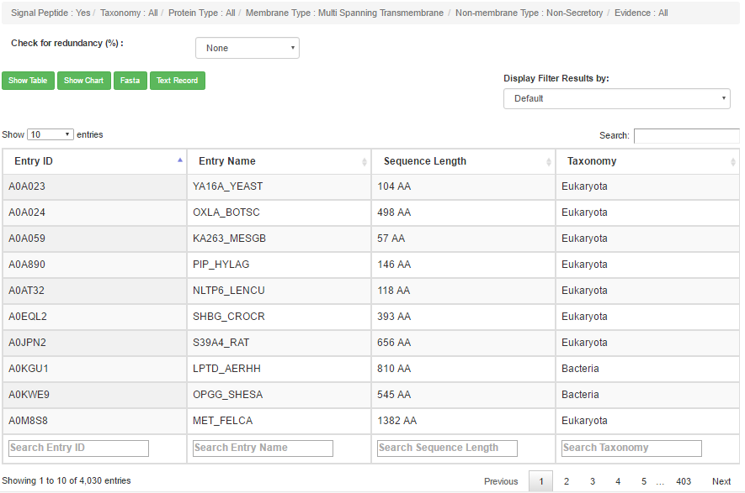

|  |  |  |  |  |
| --- | --- | --- | --- | --- |
| 1. [taxonomy] ALL | [protein] ALL | [nonmembrane] Non-secretory | [membrane] Multi-spanning | [evidence] Experimental |

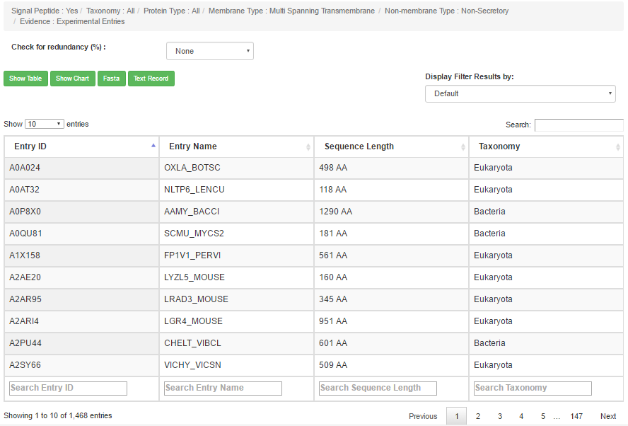

|  |  |  |  |  |
| --- | --- | --- | --- | --- |
| 1. [taxonomy] ALL | [protein] ALL | [nonmembrane] Non-secretory | [membrane] Multi-spanning | [evidence] Nonexperimental |

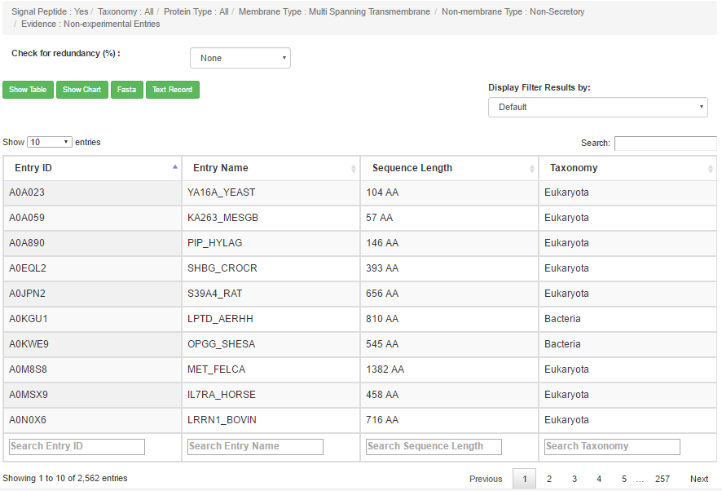

|  |  |  |  |  |
| --- | --- | --- | --- | --- |
| 1. [taxonomy] ALL | [protein] ALL | [nonmembrane] Non-secretory | [membrane] Beta-barrel | [evidence] ALL |

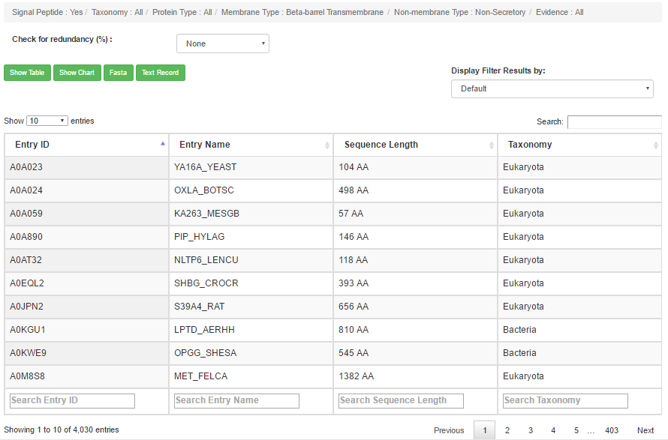

|  |  |  |  |  |
| --- | --- | --- | --- | --- |
| 1. [taxonomy] ALL | [protein] ALL | [nonmembrane] Non-secretory | [membrane] Beta-barrel | [evidence] Experimental |

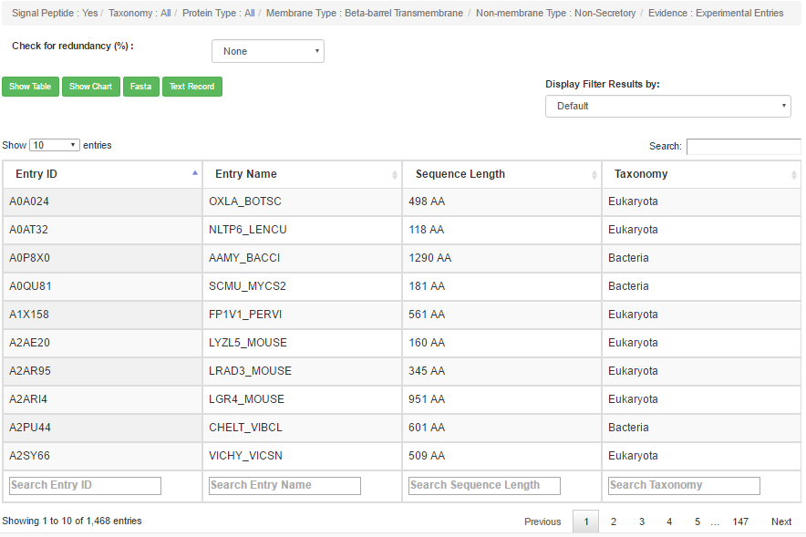

|  |  |  |  |  |
| --- | --- | --- | --- | --- |
| 1. [taxonomy] ALL | [protein] ALL | [nonmembrane] Non-secretory | [membrane] Beta-barrel | [evidence] Nonexperimental |

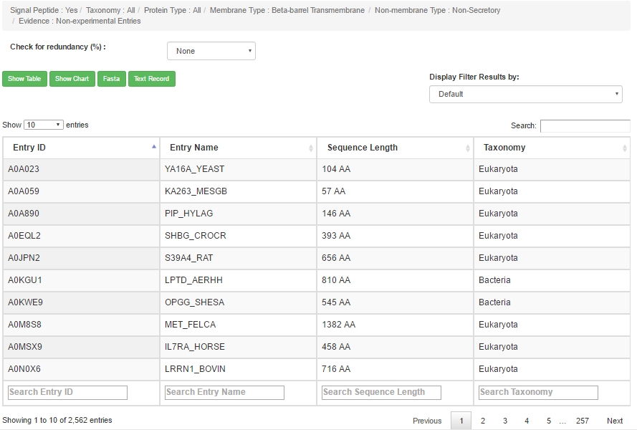

|  |  |  |  |  |
| --- | --- | --- | --- | --- |
| 1. [taxonomy] ALL | [protein] Transmembrane | [nonmembrane] ALL | [membrane] ALL | [evidence] ALL |

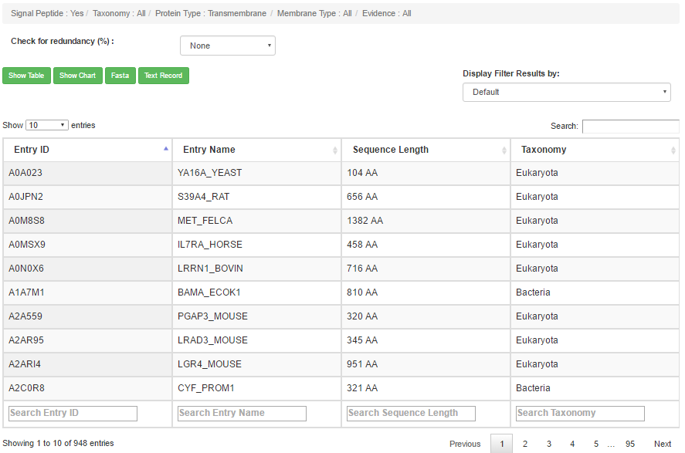

|  |  |  |  |  |
| --- | --- | --- | --- | --- |
| 1. [taxonomy] ALL | [protein] Transmembrane | [nonmembrane] ALL | [membrane] ALL | [evidence] Experimental |

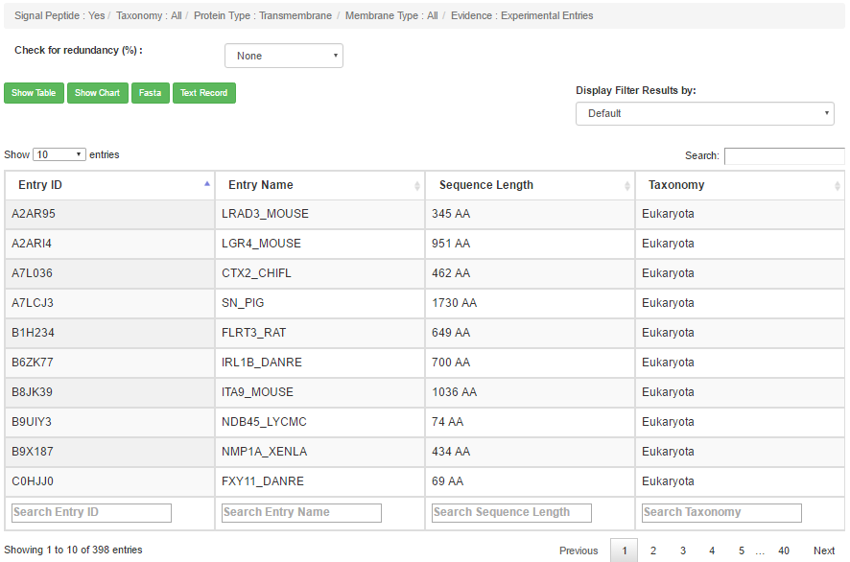

|  |  |  |  |  |
| --- | --- | --- | --- | --- |
| 1. [taxonomy] ALL | [protein] Transmembrane | [nonmembrane] ALL | [membrane] ALL | [evidence] Nonexperimental |

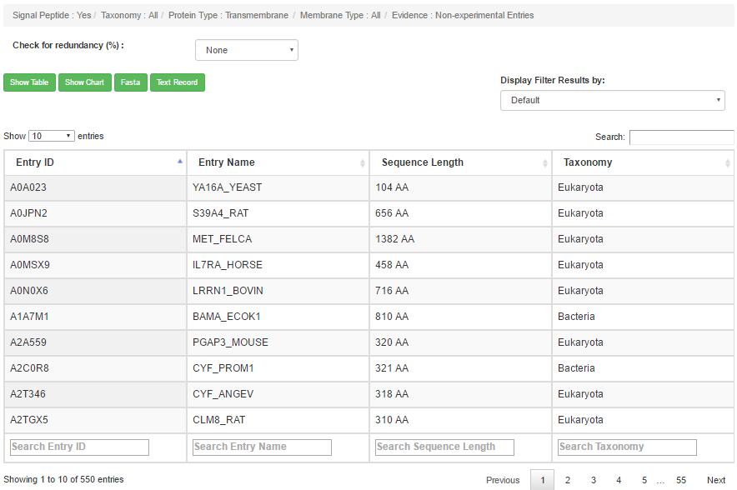

|  |  |  |  |  |
| --- | --- | --- | --- | --- |
| 1. [taxonomy] ALL | [protein] Transmembrane | [nonmembrane] ALL | [membrane] Single-spanning | [evidence] ALL |

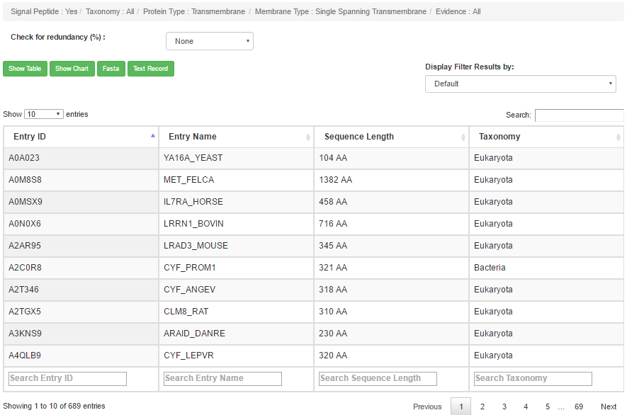

|  |  |  |  |  |
| --- | --- | --- | --- | --- |
| 1. [taxonomy] ALL | [protein] Transmembrane | [nonmembrane] ALL | [membrane] Single-spanning | [evidence] Experimental |

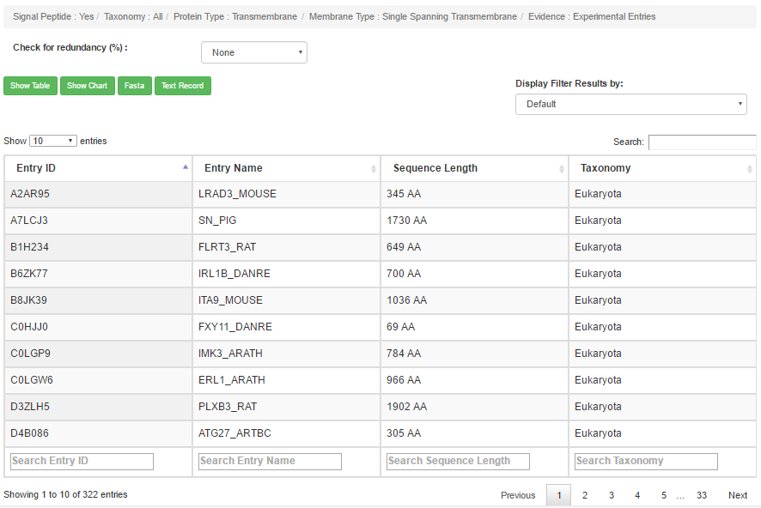

|  |  |  |  |  |
| --- | --- | --- | --- | --- |
| 1. [taxonomy] ALL | [protein] Transmembrane | [nonmembrane] ALL | [membrane] Single-spanning | [evidence] Nonexperimental |

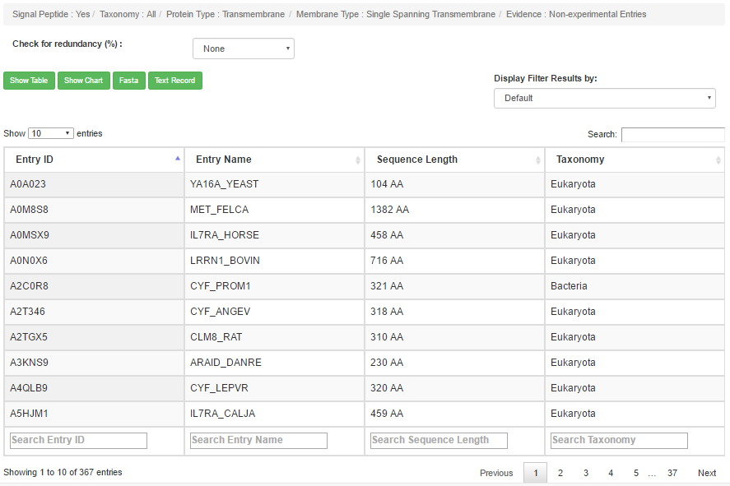

|  |  |  |  |  |
| --- | --- | --- | --- | --- |
| 1. [taxonomy] ALL | [protein] Transmembrane | [nonmembrane] ALL | [membrane] Multi-spanning | [evidence] ALL |

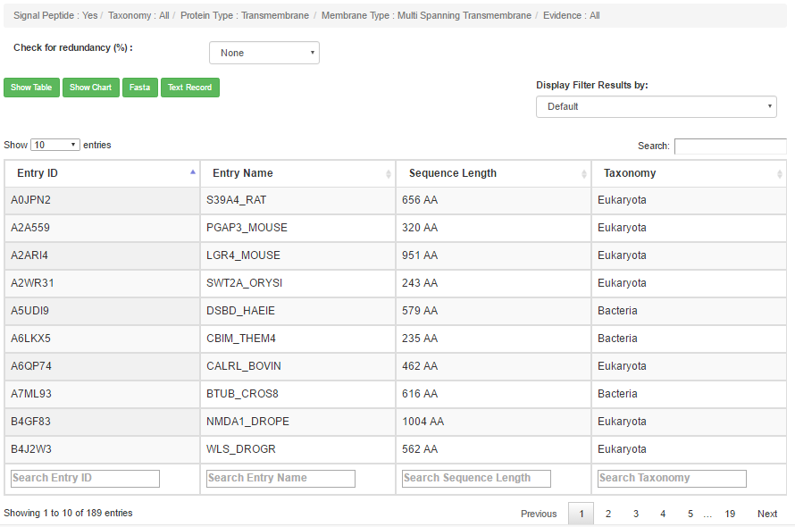

|  |  |  |  |  |
| --- | --- | --- | --- | --- |
| 1. [taxonomy] ALL | [protein] Transmembrane | [nonmembrane] ALL | [membrane] Multi-spanning | [evidence] Experimental |

